THERMO-BLOCK
Building system

- Nearly zero energy requiring houses
- A+, passive houses
O
M
R
E
H
T
C
O
L
B

years of
K
15

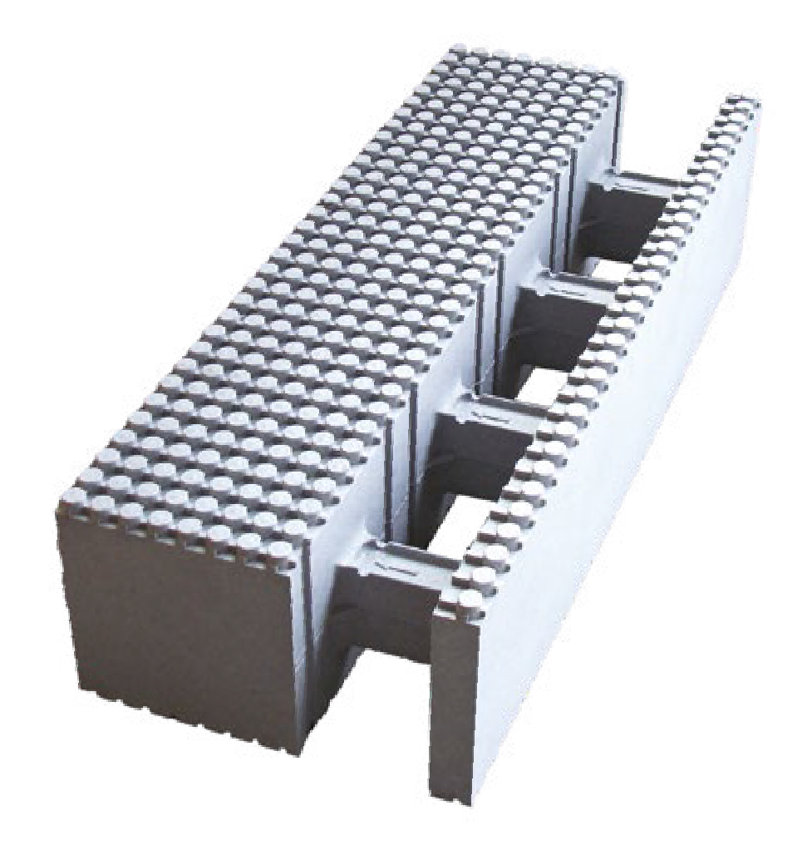

- Up to 60-70% energy saving
-
- No post-insulation
- Fast, clean implementation
- No fume and mould
- Thinner walls and more floorspace
- Massive structure, Lego-like connections
- Precise interlock
Thermo-Block Magyarország Kft.
www.thermo-block.hu • info@thermo-block.hu Management / Professional questions: +36 20/350-6750 Marketing / Financial questions: +36 20/345-7870

COMPANY GUIDE
Thermo-Block Magyarország Ltd. is a Hungarian private-owned business, the main profile of which is the production of the Thermo-Block energy saving building system, the so-called 'ICF' (heat insulated, louver retaining) technology.
ENERGY PRICES ARE GROWING ALL OVER THE WORLD
and customers expect to build and maintain their homes at a reasonable price.
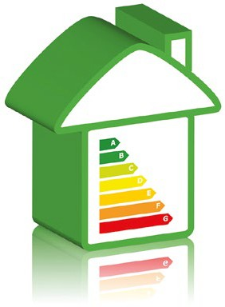
Thermo-Block Magyarország Ltd is determined to offer a high-tech, trustworthy, adequate-to-building-market, heat insulated building system.
The main profile of our company is to produce and sell Thermo-Block building system all over the country, and to plan and build ideal homes for our customers via designers and contractors at the particular region.
The raw material of Thermo-Block energy efficient buil- ding system is Neopor F 2400, or Styropor F 415 E, expanded polysthyrol foam (EPS) produced by the German BASF company. It contains foaming and fire retardant additives.
The most important parameter of EPS is its thermal conductivity (W/m2K). The smaller this value is, the better heat insulator the material is.
This excellent value is due to the air in the closed cells that remains there.
This is why the Thermo-Block energy-efficient building system does not lose its thermal insulation capacity.

The elements of Thermo-Block building system are inert,
and do not contain materials hazardous to the environment.

TABLE OF CHARGES

THERMO-BLOCK MASONRY SYSTEM
The following prices are net list and ex-works prices. They are valid from 01.01.2024. until withdrawn. Our current prices can be found at www.thermo-block.hu. Our products are available in grey graphite as well as white colour!

WALL ELEMENT

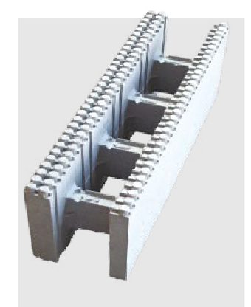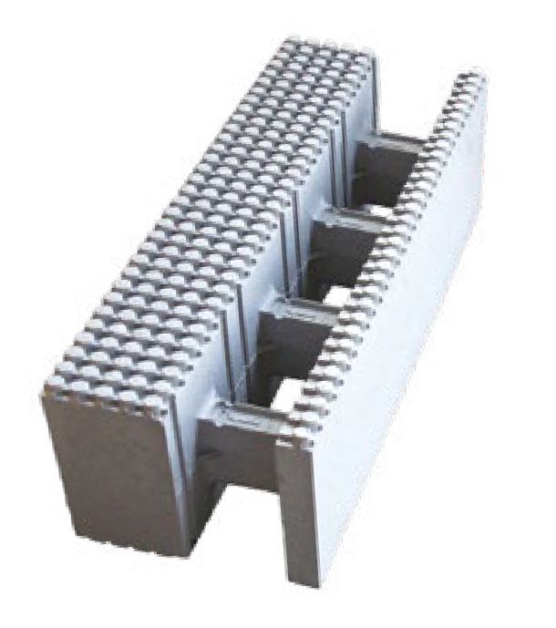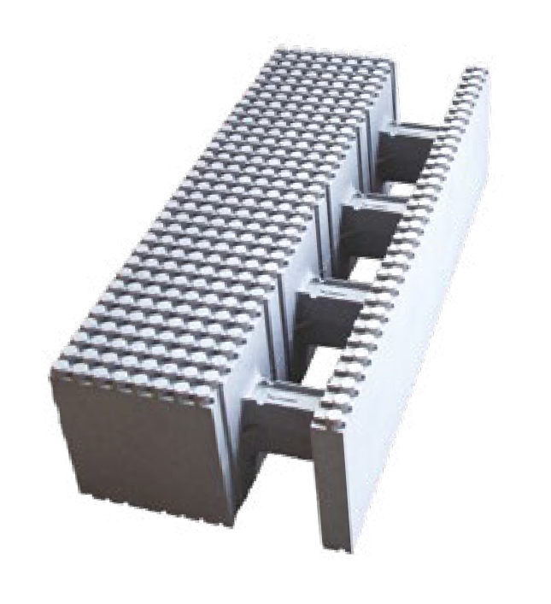

Dimension: 25x25x100 cm
Grey colour: 0,25 W/m²K White colour: 0,28 W/m²K
Grey Net cost: 42 EUR/m2
White Net cost: 38 EUR/m2
Dimension: 35x25x100 cm
Grey colour: 0,13 W/m²K White colour: 0,15 W/m²K
Grey Net cost: 60 EUR/m2
White Net cost: 54 EUR/m2
Dimension: 44x25x100 cm
Grey colour: 0,09 W/m²K White colour: 0,11 W/m²K
Grey Net cost: 78 EUR/m2
White Net cost: 70 EUR/m2

CLOSING ELEMENT

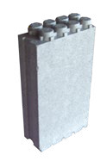
Dimension: 14x25x6,5 cm
This element serves to close off wall-endings or corners, providing precise structuring by sliding being slid into the wall elements’ grooves.

Grey Net cost: 1 EUR/piece
White Net cost: 0,9 EUR/piece

TABLE OF CHARGES

THERMO-BLOCK MASONRY SYSTEM
The following prices are net list and ex-works prices. They are valid from 01.01.2024. until withdrawn. Our current prices can be found at www.thermo-block.hu. Our products are available in grey graphite as well as white colour!

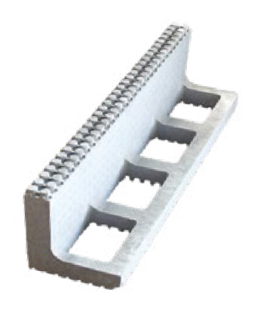
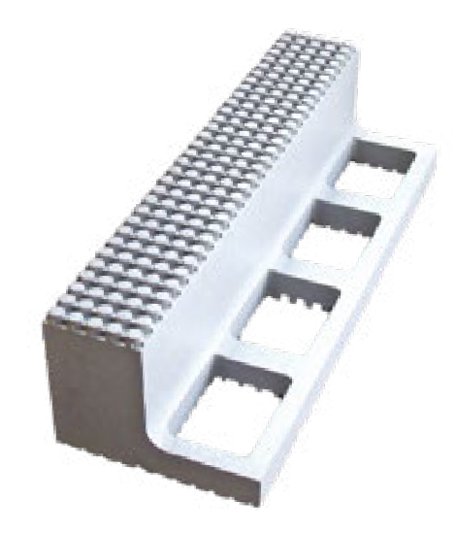
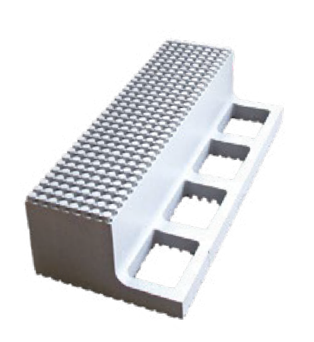
RING BEAM ELEMENT

Dimension: 25x25x100 cm Grey colour: 0,25 W/m²K White colour: 0,28 W/m²K Grey Net cost: 15 EUR/meter
White Net cost: 13,5 EUR/meter
Dimension: 35x25x100 cm Grey colour: 0,13 W/m²K White colour: 0,15 W/m²K Grey Net cost: 18 EUR/meter
White Net cost: 16 EUR/meter
Dimension: 44x25x100 cm Grey colour: 0,09 W/m²K White colour: 0,11 W/m²K Grey Net cost: 21 EUR/meter
White Net cost: 19 EUR/meter

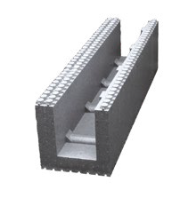
LINTEL ELEMENT

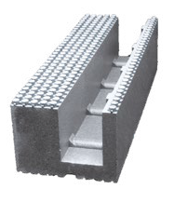
Dimension: 25x25x100 cm Grey colour: 0,25 W/m²K White colour: 0,28 W/m²K Grey Net cost: 15 EUR/meter
White Net cost: 13,5 EUR/meter
Dimension: 35x25x100 cm Grey colour: 0,13 W/m²K White colour: 0,15 W/m²K Grey Net cost: 18 EUR/meter
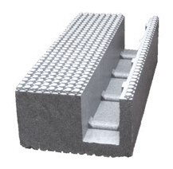
White Net cost: 16 EUR/meter
Dimension: 44x25x100 cm Grey colour: 0,09 W/m²K White colour: 0,11 W/m²K Grey Net cost: 21 EUR/meter
White Net cost: 19 EUR/meter

THERMO-BLOCK HOUSES

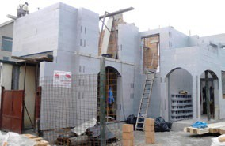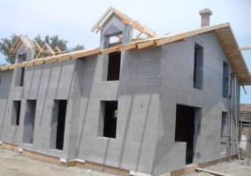
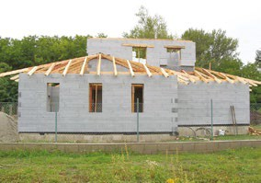
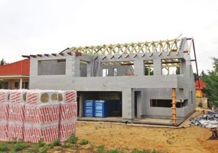
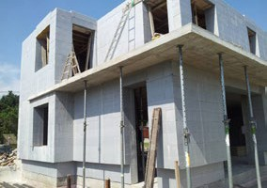
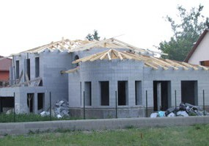

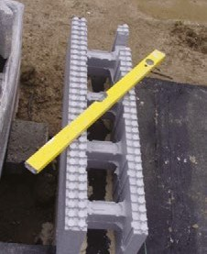
THERMO-BLOCK MASONRY

PROCESS OF IMPLEMENTATION
To utilize the advantages of the Thermo-Block unit’s dimensional accuracy, attention should be paid
to the dimensional accuracy of the receiving structure.
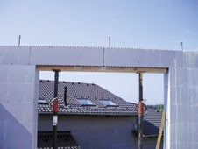
It does not require special foundations, so it can be built upon any traditional structure. The insulation against ground moisture needs to be placed beneath the first layer of building blocks. During the adjustment of the first layer the horizontal and vertical position of the building blocks needs to be carefully adjusted as well. It is advisable to start placing the blocks at the corners. After fixing, the blocks should be filled with concrete to half their height, followed by fine setting. After pouring concrete into the first layer, three layers of building blocks should be placed down and filled with concrete up to half the height of the upper layer. The concrete should be of minimum C 12 – 24 KK quality. The corners and endings are created by the combined use of building blocks and penstock. When cutting the elements at the corners it is important that the concrete pours everywhere it needs to.

THERMO-BLOCK LINTEL
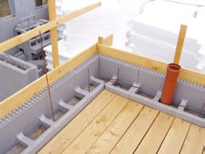
The lintels must be placed one after another on the pre- placed abutments. The bearing of the lintels should be at least 25 cms on both sides of the walls. Its base plate should be cut out at the bearing so that the connection of concrete will be continuous.

THERMO-BLOCK RING BEAM
The ring beams are connected to the last layer of building blocks. The blocks should be cut, and while filling them with concrete they must be in a fixed position. The ring beams should be held with planks.

WHY THERMO-BLOCK?

CUSTOMERS
- Low building costs
- Up to 60-70% savings on heating
- Fast and clean implementation
- No allergy, no mould
- No pallet costs
- Full system, perfect thermal insulation, no thermal bridge

MERCHANTS
- Marketing via merchant
- No competition of prices
- Material wrapped up in bales and banded
- No pallet that would need to be taken back to the manufacturer
- No need to keep stock, everything is transported to the building site

BUILDING CONTRACTORS
- Training and assistance is provided
- No need to carry heavy elements, no physical exhaustion
- No brick-cutter needed, a simple saw is enough
- Only one specialist is needed, others are helpers
- Wire-holes can be cut with hot-wire foam cutters instead of a milling cutter; no noise, no dust
- The slab is supported with expanded kickstand and no louver board
- No crane is needed to move the elements

INVESTORS
- Low energy requirement, A+ houses, passive houses
- Up to 60-70% energy saving
- Easier to sell due to cheaper maintenance fees
- Fast, cheap, waste-free implementation
- Thinner walls, bigger floor-space
- Low construction costs
- “U” value meets heating requirements, no post insulation needed
YOUR MERCHANT IS:

